**CST-105: Exercise 8 - Implementing a Class**

The following exercise assesses your ability to do the following:

* Translate a model into software by implementing a class.
* Utilize class objects in a programming solution.

1. Read this document carefully and review the rubric for this assignment before beginning work. Be sure you are familiar with the criteria for successful completion. The rubric link can be found in the digital classroom under the assignment.
2. In this assignment, you are implementing a class from a model shown here.  
     
   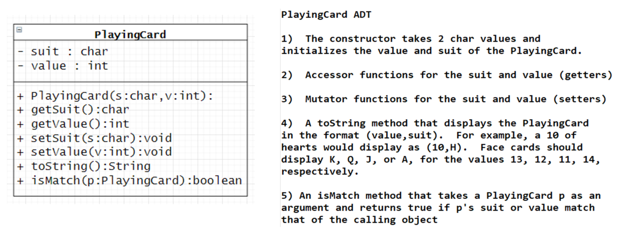

After writing the class, test each function in a main method before proceeding to the next steps.

1. Once your class is fully tested, write a driver method that does the following:
   1. Creates an ArrayList of 52 cards
   2. Fills the deck with standard playing cards
   3. Randomly selects two cards from the deck and compare the cards to see if they match

A sample run can be found at the end of this assignment.

1. Create a video in which you present your class implementation and your driver program. Videos over 5 minutes in length will not be accepted.
2. Submit the following in the digital classroom:
3. Your Java code for both the driver program and the class implementation
4. A link to your video

Sample program runs:   
  
